Grade 6 (Heritage and Identity) Place-based Learning Lesson Plan
TC Name: Emily Wright

Grade and Strand: Grade 6 – Heritage and Identity: Communities in Canada, Past and Present

Lesson Topic and Critical Inquiry: Place-based Learning at Kortright Center and investigating Indigenous ways of life pre-contact / settlement. Investigating the impact of settlement.

Lesson Description. Includes focus on Disciplinary Thinking Concepts and Inquiry work
This placed-based lesson gives students the opportunity to learn more about Indigenous communities and their way of life before the arrival of settlers. Through a trip to the Kortright Center for Conservation, located in Vaughan, Ontario, students will learn about the daily life of Huron people. This trip will give students insight into the early life of Indigenous peoples in Ontario and assist them in investigating how the Indigenous community in Canada has changed over time and why these changes have occurred. The trip will consist of two parts: in the morning, students will explore Early Indigenous Life, and in the afternoon, students will participate in an art-based activity which will allow them to further connect to the land and nature. It is hoped that through this trip students will inquire about the impact of settlement on Indigenous ways of life. This lesson will also assist in the development of student inquiry skills, data gathering, and making informed conclusions by examining data from multiple sources.

The social studies disciplinary thinking concepts focused on in this lesson are, significance, continuity and change, interrelationships, and perspective.
- Significance
  - Through this trip students will determine the importance / impact of contact, development of traditional Indigenous land, and interrelationships between Indigenous peoples and settlers. How do we determine the importance of this land? How do we determine the importance of events which occurred between Indigenous peoples and settlers? Who are these events important for and why? Why might some people deem these events to be significant, but others may not? What were the short and long-term impacts of contact and do those impacts effect the significance of such an event?
- Continuity and Change
  - Through the exploration of early Indigenous life, students can determine what has stayed the same and what has changed over a period of time. Students can explore continuity and change in Indigenous communities in terms of way of life, political policies, relationships with the environment, etc. Students can make comparisons between early Indigenous life explored at the Kortright Center (approx. 400 years ago) and the present. In what ways has Indigenous way of life changed from the past to present-day? Has anything stayed the same? What are some of the causes for this change? What environmental techniques used by Indigenous peoples have been adapted by settlers / Canadian society at large? Which historic policies, put into place to control Indigenous communities in Early Canada, still exist today (or forms of these policies)?
- Interrelationships
  - This concept explores the connections within and between natural and/or human systems and how they adapt to one another or impact one another. Through the exploration of Indigenous life, students will explore the impact humans have had on each other. Students can also explore the relationship between Indigenous worldviews and nature. Through the art activity, students can explore their own impact on the natural world and if the relationship they have with nature is one which is respectful and reciprocal. How did Indigenous peoples treat nature? Was the relationship reciprocal? How did Indigenous people and settlers influence the lives of each other? Was there reciprocity in their relationship (or an exchange of some sort)?
- Perspective
  - Through this lesson students will explore the ways different groups (Indigenous communities, settlers, etc.) view traditional Indigenous land, the impact of contact, the natural world, etc. Students will learn that different groups have different perspectives which are impacted by a variety of factors. This lesson will also assist students in developing their critical thinking and analysis skills to determine which voices are and are not present in data and how to conduct inquiry which takes into account multiple perspectives and voices. Whose voices are most prominent when talking about issues related to Indigenous rights, in the past and present-day? Are those voices changing? Whose perspective does this data source convey? What differences in facts can you find when examining two different perspectives?

Lesson Connection to Culminating/Summative for the Unit
The summative or culminating task for this unit requires students to create “Heritage Minutes” videos in small groups. “Heritage Minute” videos are videos which depict a moment in Canadian history / heritage depicted in a 1 to 2-minute clip. “Heritage minutes”, created by Historic Canada in the early 1990s, depict small defining moments in Canada’s history but they have often been seen to be historically inaccurate. For their summative or culminating task, students will examine a “Heritage Minutes” clip related to a community of choice in Canada. Students will examine and investigate the clip and determine its historical accuracy, any biases present, and which perspectives are and are not present in the clip. Using the data and research they have collected throughout the unit on their community of choice, students will then create their own “Heritage Minute” which reflects the history and voice of that community.
This lesson will give students a better understanding of Indigenous communities in Canada in both the past and the present. Students can use the information gathered and learned through this lesson to inform their analysis of a “Heritage Minute” or the creation of their own “Heritage Minute”. Understanding various perspectives, looking at various sources of data (primary and secondary), and learning to ask critical question about data are all aspects of this lesson which build towards the summative or culminating task.

Lesson Planning and Curriculum Expectations
Social Studies Overall and Specific Curriculum Expectations
A1. Application: assess contributions to Canadian identities made by various groups and communities, including First Nations, Metis, and Inuit communities, and by various features of Canadian communities and regions
A1.1 Explain how various features, including built, physical, and social features of communities, can contribute to identities in and images of a territory and/or country
A1.2 Analyse some of the contributions that various First Nations, Métis, and Inuit communities and individuals have made to Canada
A1.3 Analyse some of the contributions that various settler/newcomer groups have made to Canadian identities

A2. Inquiry: use the social studies inquiry process to investigate different perspectives on the historical and/or contemporary experiences of a few distinct communities, including First nations, Metis, and/or Inuit communities, in Canada
A2.1 Formulate questions to guide investigations into different perspectives on the historical and/or contemporary experiences of a few distinct communities, including First Nations, Métis, and/or Inuit communities, in Canada
A2.2 Gather and organize information from a variety of primary and secondary sources
A2.5 Evaluate evidence and draw conclusions about perspectives on the historical and/or contemporary experience of a few distinct communities, including First Nations, Métis, and/or Inuit communities, in Canada

A3. Understanding Context: demonstrate an understanding of significant experiences of, and major changes and aspects of life in, various historical and contemporary communities, including First Nations, Metis, and Inuit communities, in Canada
A3.1 Identify the traditional Indigenous and treaty territory or territories on which their community is located
A3.4 Identify various types of communities in Canada and some ways in which they have contributed to the development of the country
A3.5 Describe significant events or developments in the history of two or more First Nations, Métis, and/or Inuit communities in Canada
A3.7 Describe interactions between communities in Canada, including between newcomers and groups that were already in the country
A3.8 Identify key differences, including social, cultural, and/or economic differences, between a few historical and/or contemporary communities, including at least one First Nations, Métis, or Inuit community, in Canada

Visual Arts Overall and Specific Curriculum Expectations
D1. Creating and Presenting: apply the creative process (see pages 19–22) to produce art works in a variety of traditional two- and three-dimensional forms, as well as multimedia art works, that communicate feelings, ideas, and understandings, using elements, principles, and techniques of visual arts as well as current media technologies
D1.1 Create two-dimensional, three-dimensional, and multimedia art works that explore feelings, ideas, and issues from a variety of points of view
D1.2 Demonstrate an understanding of composition, using selected principles of design to create narrative art works or art works on a theme or topic
D1.3 Use elements of design in art works to communicate ideas, messages, and understandings

D2. Reflecting, Responding, and Analysing: apply the critical analysis process (see pages 23–28) to communicate feelings, ideas, and understandings in response to a variety of art works and art experiences
D2.2 Explain how the elements and principles of design are used in their own and others’ art work to communicate meaning or understanding

D3. Exploring Forms and Cultural Contexts: demonstrate an understanding of a variety of art forms, styles, and techniques from the past and present, and their sociocultural and historical contexts
D3.1 Identify and describe some of the ways in which art forms and styles reflect the beliefs and traditions of a variety of communities, times, and places

Learning Goals:
Learning goals for this lesson are:
- To learn about the way of life and worldviews of the Indigenous community through place-based learning / experiential and hands-on learning
- To learn about the past and the present of the land
- Learn about the impact of contact / colonization on Indigenous communities in Canada
- Examine and understand different perspectives of the lives of Indigenous peoples before and after contact

Critical Thinking Question(s)
Critical thinking questions posed to students should go beyond questions with a simple yes or no answer. Questions posed should require students to investigate, gather evidence, and analyse information. It is important to remember that critical thinking questions are not asked to lead students towards a right answer, but rather to develop their reflective and inquiry skills. Teachers should evaluate the accuracy and strength of evidence, the depth and logic of their analysis, and how well they can support their conclusions.

Critical thinking questions posed to students for this lesson:
- What was the impact of contact on Indigenous communities in Canada?
  - Was the impact positive, negative, or both?
- How has contact impacted present-day indigenous communities?
- The Kortright Center is situated on the traditional land of the Huron-Wendat people. Who do you think this land rightfully belongs to? Why?
  - How do you think leaving the land impacted the way of life of Huron-Wendat people?
  - What would be the impact of returning the land to the Huron-Wendat people? What is the impact of not returning it?
- Can the loss of land lead of a loss of identity or way of life for communities? Explain your thinking.
  - Think about your own family. Did your family (you, your parents, or your grandparents) move to Canada from a different part of the world? Did this move impact your family’s traditions, food, language, or customs? Is your day-to-day life different from that of your family in different parts of the world?

Key Vocabulary
Key vocabulary for this lesson is: contributions, identity, community, Indigenous, First Nations, inquiry, historical, contemporary, way of life, impact, traditions, perspective, colonization, contact, settler, decolonization, relocation, reflect, evidence, traditional territory, and displacement.

Links to Indigenous Knowledge/ Place-Based Curriculum Pedagogy
Through this lesson, students will gain a better understanding of Indigenous communities and their worldviews. Students will also gain a better understanding of Indigenous knowledge, its roots, and how it is passed down (oral history, storytelling). This lesson also aims to help students see Indigenous knowledge as a legitimate form of knowledge outside of Eurocentric knowledge creation.

In order to help students gain an authentic understanding, the main learning of this lesson will take place on the traditional land of the Huron-Wendat people. Through visiting the land and experiencing the daily life of Indigenous people before contact, it is hoped that this experiential learning opportunity will give allow students to gain a more thorough understanding of Indigenous communities, and the significance of dispossession to their way of life.
Part 1: Minds On: Connecting Background Knowledge
The minds on activities for this lesson will take place over the course of a few days before the place-based lesson / trip.

Activity 1: Vocabulary Relay Race
- Print out 5 sets of vocabulary words onto cardstock cards. Each word should be on its own card. Next print out 5 sets of the definitions of each vocabulary word onto cardstock cards. Each definition should be on its own card. Then, take all the sets of vocabulary words and mix them up in a pile on the floor.
- Next, divide students into 5 groups and give each group a set of the definition cards.
- To play, the teacher will read out a definition to the class. Groups will have 10 seconds to think of possible words which may correlate to that definition. After 10 seconds, the teacher will call out “WORD” and one member from each group will run to the pile of words to try and find the correct vocabulary word.
- The student in charge of finding the word will then take it to the teacher for them to check if the word is correct or not. If it is incorrect, they will have to go back to the pile and look for the correct word.
- The class will have a brief discussion about each word before moving onto the next round. After the game, the words and their definitions will be put up in the classroom for reference.
- It is important to note that this activity may not be suitable for students with mobility restrictions or visual impairments. Teachers may wish to pair students with others who can assist them or, modify the game by providing the set of vocab words to each group. When the teacher says “WORD”, students can look through the pile at their desk to find the right word. Students can call out “WORD” when they have found the correct word and the teacher will come over to check.

Activity 2: Land Acknowledgement (to be done over multiple days)
- https://native-land.ca/ is a map of North America. This map is organized by traditional Indigenous territory, Indigenous language, and treaties.
- At the beginning of the class, open up https://native-land.ca/ and project it onto the board. Allow students to look at and explore the map on their own. Then discuss what they see, and what they think the map might be about.
- Then explain to students what the map is about and how it is organized. Have a discussion with students to create an understanding of how land was taken from first nations peoples (taken, treaties, etc.).
- Next, brainstorm as a class what a land acknowledgement might be. Have students watch “Toronto school paying tribute to Indigenous lands” <https://www.youtube.com/watch?v=8vrwMgyqUH4> and “Canadian Students Recognize Indigenous Land” <https://www.youtube.com/watch?v=YjHvKqe72GY> to help them gain a better understanding of why land acknowledgements are used in schools
- Show students some examples of various land acknowledgements and highlight the various aspects of the acknowledgement (name of traditional territory, thankful to be on land, etc.). Go back to https://native-land.ca/ and in the “Search your address or city” bar look up the address of the school. The site will display a list called “You are on the land of:”. Students can click on the Indigenous communities in the list and be taken to their official webpage.
- In pairs or individually students will go on https://native-land.ca/ and look up which traditional territory their home, school, community, and city are located on. Students will explore the list of communities and learn more about them. Students will complete an organizer (see appendix 1) which in which they write down the Indigenous communities which once lived on the land where their school is located and some information about each of those communities. Have students then create their own land acknowledgments about where the school is located (give students examples to work with). Every morning, before the school day, have one student read out their land acknowledgment to the class.
- Explain to students that they will be going to the Kortright center to learn more about Indigenous communities. Use https://native-land.ca/ and https://kortright.org/2018/01/29/early-aboriginal-life/ to learn about the Kortright center and the traditional territory it is located upon. Students will then create their own land acknowledgements for the Kortright Center.

Part 2: Action/Activities-Large and small group activities
Focused Inquiry 1  Students will be going to the Kortright Center for Conservation to learn about the daily life of Huron people, who lived on the land 400 years ago. They will be participating in the “Early Aboriginal Life” program offered at the center. This program will be a half-day (morning to lunch). A Huron elder will be leading the group. If it is not possible to have an elder lead the group, then one of the staff members of the Kortright Center will lead the program for the morning. Students will be completing their field journals (see appendix 2) while on the trip.  Students will participate in the following activities during this program:  - Discussing daily life in an Indigenous, including social structure and their life as hunters, gatherers and farmers, through a slide show and authentic artifacts  - A walk along the same route as the Carrying Place trails, so students can actually walk in same place as past settlers and First Nations peoples native to the land. On the walk, the students will be shown plants and other natural resources which were used as food, medicine, tools, and household items. Students will also participate in a “Shopping Trip”, in which they will look for items the Huron people would have used in their day-to-day lives. The shopping trip will emphasize the scarcity of some resources and the importance of resource conservation.  - Students will then walk along the Humber Valley, and consider the best spot for situating a village. This activity will allow students to understand the relationship between Indigenous people and the physical environment.  - Lastly, students will complete chores done in a Huron village such as, grinding corn and using a drill bow to light a fire.  - Students will then participate in a circle with the elder to consolidate their morning and learnings. Students can ask questions, gain clarifications, or share their feelings about the morning.  - Students will then have some time to work on their field journals before lunch.  Social studies disciplinary thinking concepts addressed in this focused inquiry are significance, continuity and change, interrelationships, and perspective.  Focused Inquiry 2  After lunch, students will be participating in the “Art in Nature” program offered at the Kortright center. Led by a staff member of the center, students will create ephemeral art, art which is made directly on the landscape using the natural objects available in that landscape. This style of art allows for students who may not excel at traditional form of art (paper and pencil, painting, etc.) a chance to express themselves and their creativity. Teachers can take pictures of students work to save the art.  This program will also builds upon student’s understandings of resources available in the environment, and relationships with the physical environment from the morning workshop. Students will continue to work on their field journals.  Through this program, students will:  - Create place-based art with natural objects found in the natural environment  - Experience hands-on contact with natural objects  - Closely observe, and gain a better understanding of key visual arts concepts  Social studies disciplinary thinking concepts addressed in this focused inquiry are interrelationships, and perspective. |  | Materials and Set up  - Class set of field journals  - Class set of clipboards  - Class set of pencils  Teaching/Learning Strategies  - Whole class work  - Individual work  - Drawing, writing, reflecting  Materials and Set up  - Class set of field journals  - Class set of clipboards  - Class set of pencils  - Teacher Camera  Teaching/Learning Strategies  - Whole class work  - Small group / pair work  - Individual work  - Hands-on work  - Drawing, writing, reflecting
Assessment: Tools and Strategies
Students will be assessed on the completion of their guided field study journals on their trip to the Kortright center. The journal includes sketching, reflecting, and a self-assessment. Completion of the journal will be assessed through descriptive feedback for a completion mark. The field journal will also serve to inform the teacher about any misconceptions the student may have and about what needs to be addressed further.

Success Criteria created with students:
- My field journal has been completed to the best of my abilities
- I took my time in completing my sketches and provided a brief explanation about them (what it is and why it is significant to me)
- My reflection was thoughtful and reflects what I have learned at the Kortright center
- I have created a land acknowledgement for the Kortright Center and included it in my field journal
- I have answered all the questions in the field journal
- I have re-read my field journal and corrected any spelling or grammar mistakes
- My field journal is a good source of information that I can use later on
- I have completed the self-assessment questions at the back of my field journal

Assessment for and as learning is assessment with the purpose of improving student learning. Assessment for learning requires teachers to provide students with descriptive feedback and coaching for improvement. In this lesson, teachers will provide students with descriptive feedback on their field study journals. Assessment as learning requires teachers to assist students in developing their capacity to be independent, autonomous, reflective, and reflexive learners who are able to set goals, monitor their own progress and create next steps. In this lesson, teachers will make observations of their students on a class chart (see appendix 3). Teachers will also look at the students field journals to inform their understandings of student progress. Students will also complete self-evaluations (see appendix 2) which can be used to inform teacher assessment of students as learners.

Assessment of learning or evaluation, is the process of judging the quality of student learning. For this lesson, the student field journal will be assessed based on established performance standards. Feedback will be provided in the form of descriptive feedback.

Assessment Tools
- Descriptive feedback
- Anecdotal notes
- Self-assessment
Part 3: Consolidation and Debrief
The consolidation of this field study lesson will occur the day after the field trip. The following day, students will be given time to complete their field journals, review them, and make any changes they deem necessary. While students have already participated in a circle experience with the elder at the Kortright center, students will participate in one more “wrap-up” circle in class. This circle will be facilitated by the teacher and will give students an opportunity to share their experience at the Kortright center (What did I learn? What is still unclear to me? What surprised me? Etc.). Students will also be given the opportunity to share with their classmates any of the sketches they created while on the trip. It is important to note that participation in the circle can occur in various ways for different students. Some students may wish to sit in the circle and share their thoughts while others may wish to sit in the circle and just listen.

Success Criteria for consolidation circle created with students:
- I have the right to participate or pass in this circle
- I am respectful to myself, and my peers
- I do not talk when others are talking
- I am attentive
- I am respectful on the views and understandings of others
- I do not share what has been discussed in this circle with people who have not participated in the circle
- If I want to share or use something someone has said, I must ask permission first
- The circle is a safe space for everyone

Reflection strategies include,
- Giving time to reflect individually before sharing as a group
- Giving students a few different questions or sentence starters
- Teacher models reflection for students

Checks for understanding
- Thumbs-up / thumbs-down
- 2 stars and a wish
- Have students write down one new thing they learned from the circle

Considerations
Not all students learn the same way, therefore it is important to created differentiated instruction and accommodate for student needs. Ways to accommodate to the various needs of learners are:
- Allow students to complete a visual journal instead of a written one. Students can take pictures on an iPad or cellphone and later share them with the teacher.
- Allow students to create an oral journal by recording their thoughts on an iPad or cellphone.
- Students can also take pictures and type notes on an iPad or cellphone on the trip and submit that in place of a written journal.
- Provide a brief summary / notes of the talk and information orally presented for students who may need a written copy of the information shared
- Lessen the workload for students who may need it
- Allow for extra time to complete activity
- Chunk work
- Chunk instructions
- Extension activities / questions for gifted learners
- Pair ELL students with those who speak the same language as them
- Allow ELL students to write in their own language
- Translate key words or phrases for ELL students

It is important to note that a students IEP will have the most update information about them as a learner. Always refer to the IEP for specific accommodations or modifications a student has the right to.

It is also important to note that this lesson is a place-based lesson which occurs outside of the classroom. The trails and land the lesson occurs on, may not be conducive to the learning of students with mobility restrictions, or visual impairments. Teachers may wish to pick shorter trails or trails with more paved aspects to ensure the safety of students. If going to the Kortright center is not possible for some students, teachers could invite the Indigenous elder to come to the school and give a talk there. If possible, the class could sit outside on the tarmac or grass and have the talk there. While the experience may be different than the one at the Kortright center, the land the school is situated on is still the traditional territory of Indigenous peoples and students can still gain a better understanding of the land and the communities who once inhabited it.

List of All Resources Used in Lesson  [CBC News]. (2016, September 23). Toronto  school paying tribute to Indigenous lands [Video  File]. Retrieved from  https://www.youtube.com/watch?v=8vrwMgyqUH4  [AJ+]. (2017, March 25). Canadian students recog-  nize Indigenous land [Video File]. Retrieved  from  https://www.youtube.com/watch?v=YjHvKqe72GY  Native Land Net. (n.d). Native land. Retrieved  from https://native-land.ca/  Kortright Center for Conservation. (n.d). Early  Aboriginal life. Retrieved from  https://kortright.org/2018/01/29/early-aboriginal-life/  Kortright Center for Conservation. (n.d). Art in nature. Retrieved from  https://kortright.org/2018/01/29/art-in-nature/  Ontario Ministry of Education. (2018). The Ontario  curriculum, social studies grades 1 to 6. On-  tario, Canada: Queen’s Printer for Ontario.  Resources which may help to inform teacher understandings of place-based learning  Lowenstein, E., Martusewicz, R., & Voelker, L.  (2010). Developing Teachers' Capacity for  EcoJustice Education and Community-Based  Learning, Teacher Education Quarterly, 37(4),  99-118.  Sobel, D. (2005). Place-based education: Connect-  ing classrooms and communities. Great Barring  ton, MA: The Orion Society. | Reflections/Comments  While creating this lesson plan, I have tried my best to accommodate for the needs of various learners which may be present in the classroom. The goal of this lesson is to give students a better understanding of Indigenous communities, both past and present, through a place-based lesson. It is my hope that students will find not only a connection to the land, but also to the communities who once called the land home. It is my hope that all learners, regardless of their learning needs, will find this lesson informative and meaningful.  The creation of this lesson plan, at first, seemed daunting, however it quickly came together. While creating the lesson plan, I was also aware that others may wish to use this lesson plan. I tried my best to include as much explanation and detail as possible for both others and myself. For example, explaining the difference between learning as, of, and for was something I felt necessary to include to help others understand the difference between them and the need to include them. I also included a cross-curricular activity in this lesson, as subjects are not individual. They connect and intertwine with each other. Connecting a lesson to other subjects works towards giving students a more wholistic education.  It is my hope that this place-based lesson plan will be used by other teachers. I hope, through this lesson plan, other teachers can see the wealth of opportunities and curriculum connections available to us and our students in our local communities.

Appendix 1: Graphic Organizer

Fill out the graphic organizer below with some information about the original communities which once lived on this land.
Name of Community | What I have learned about them

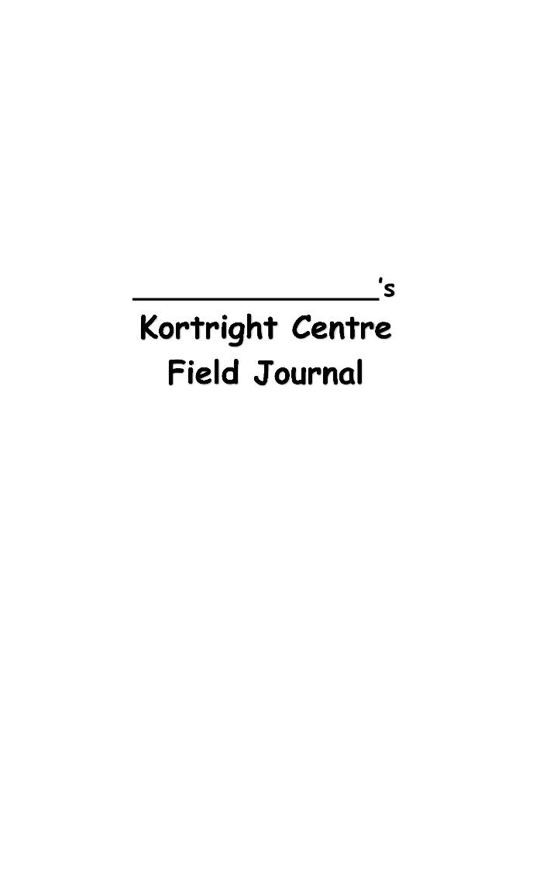
Appendix 2: Field Study Journal
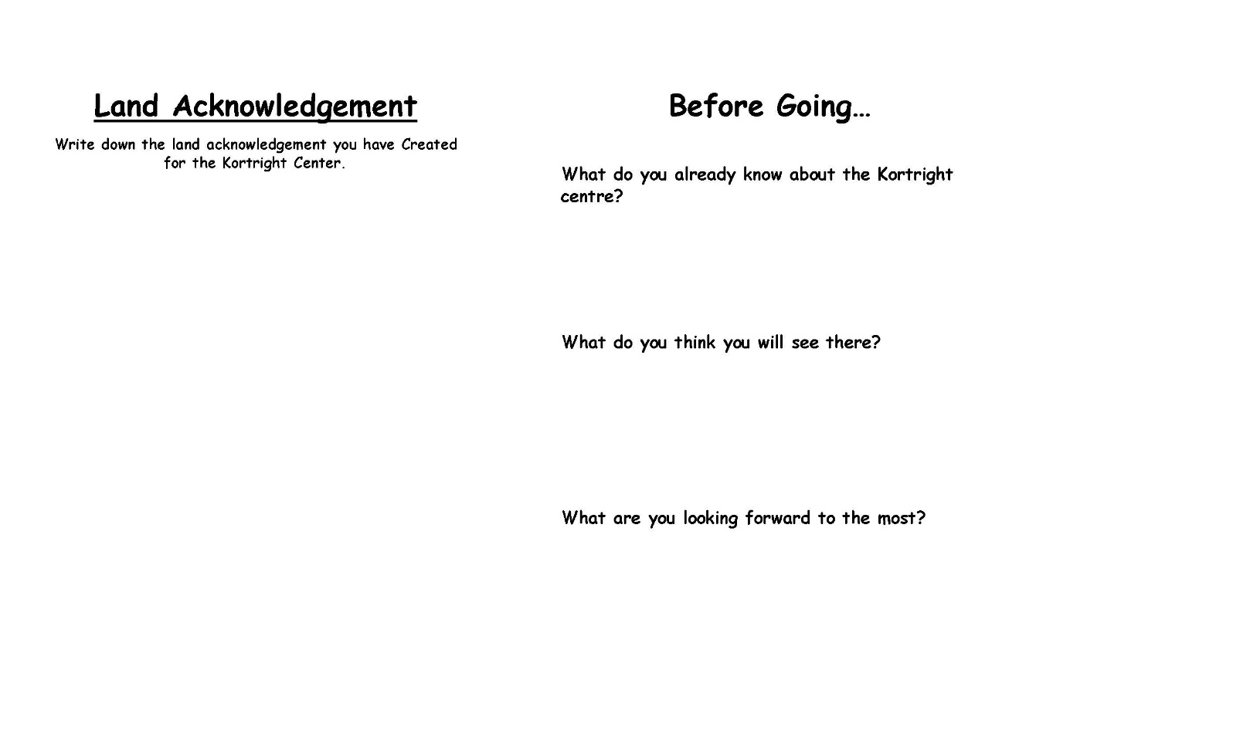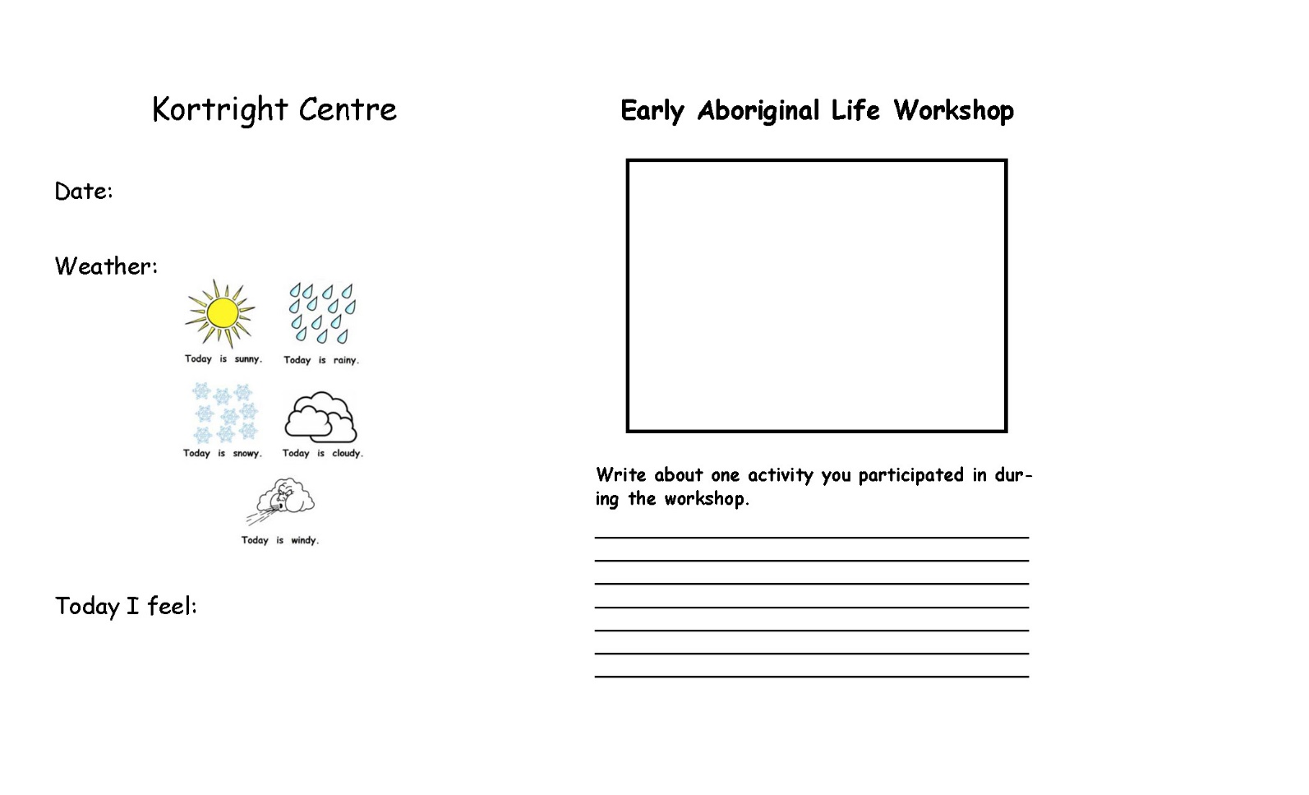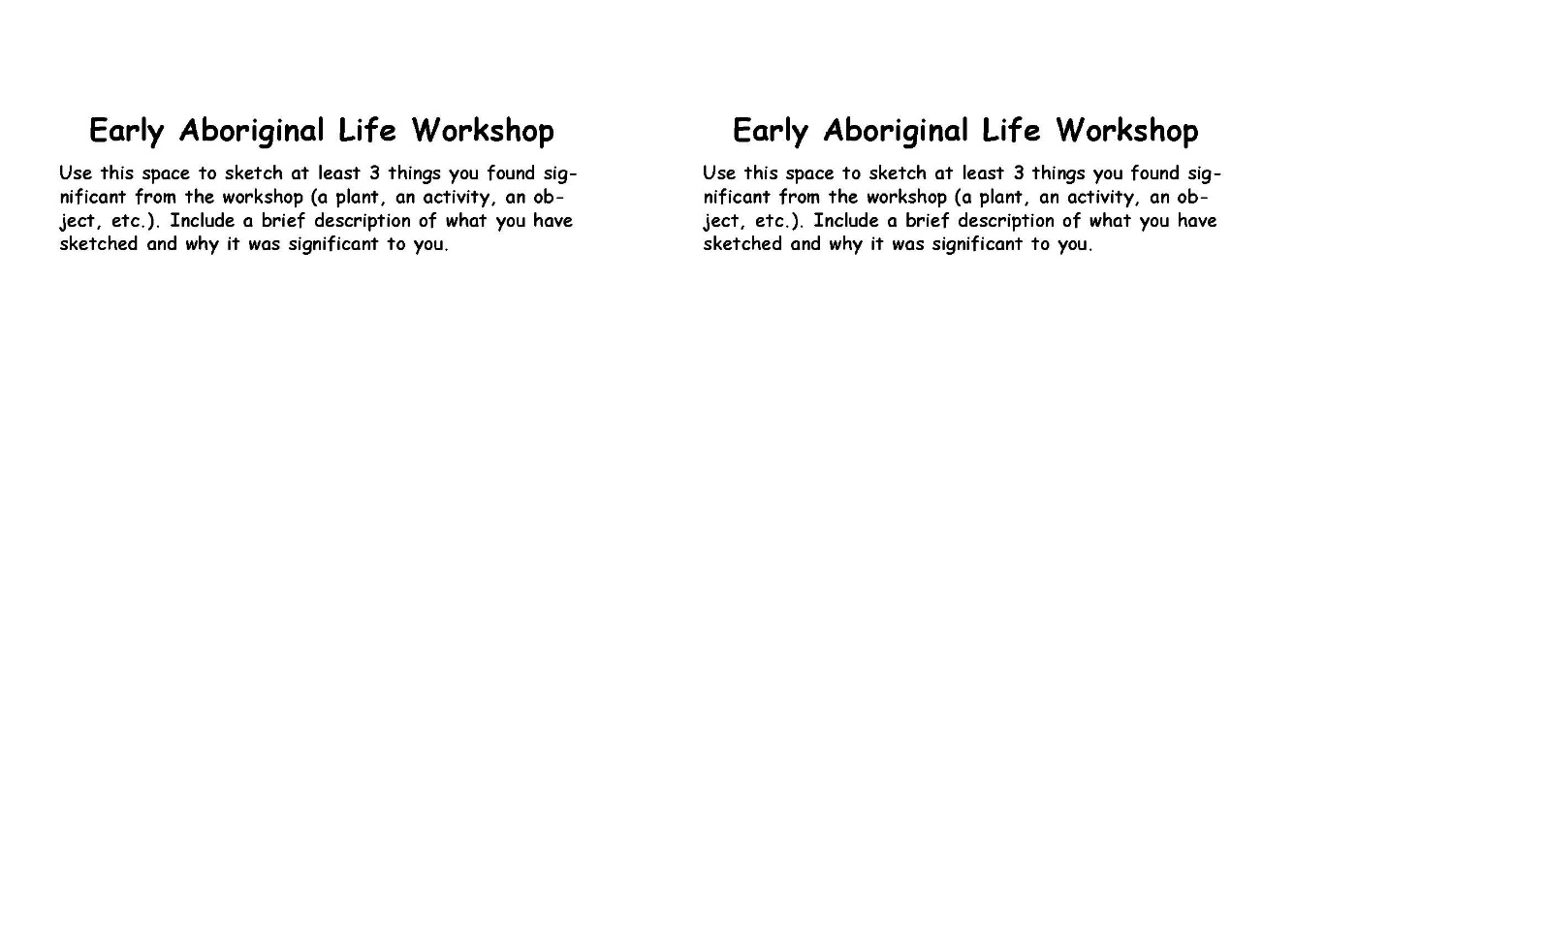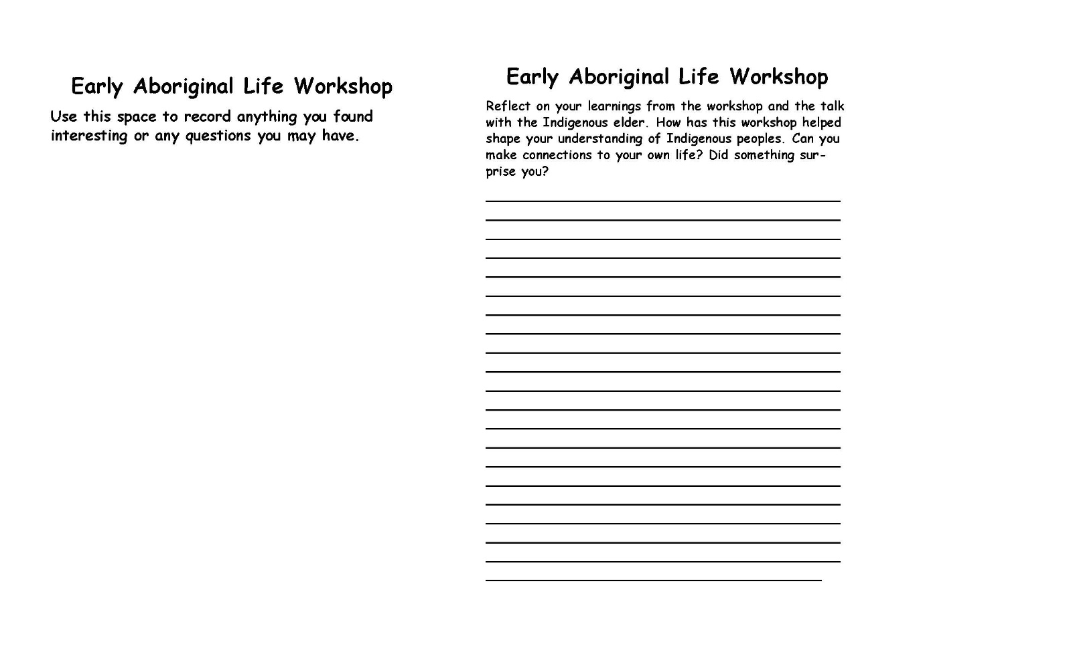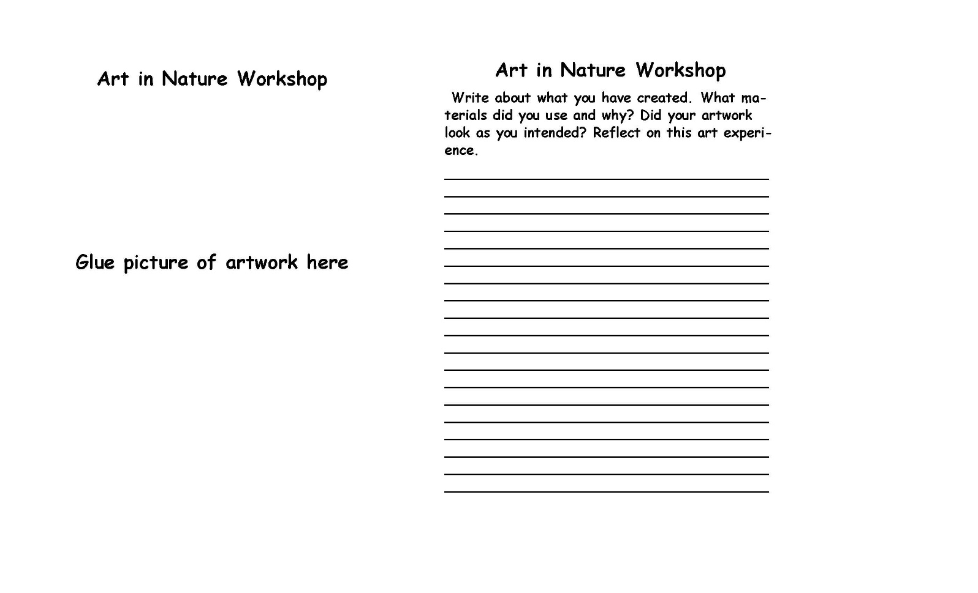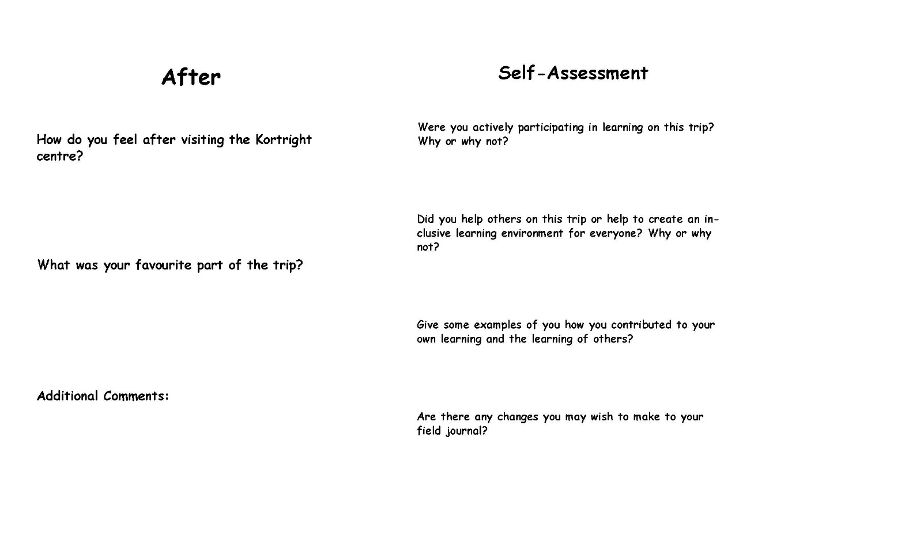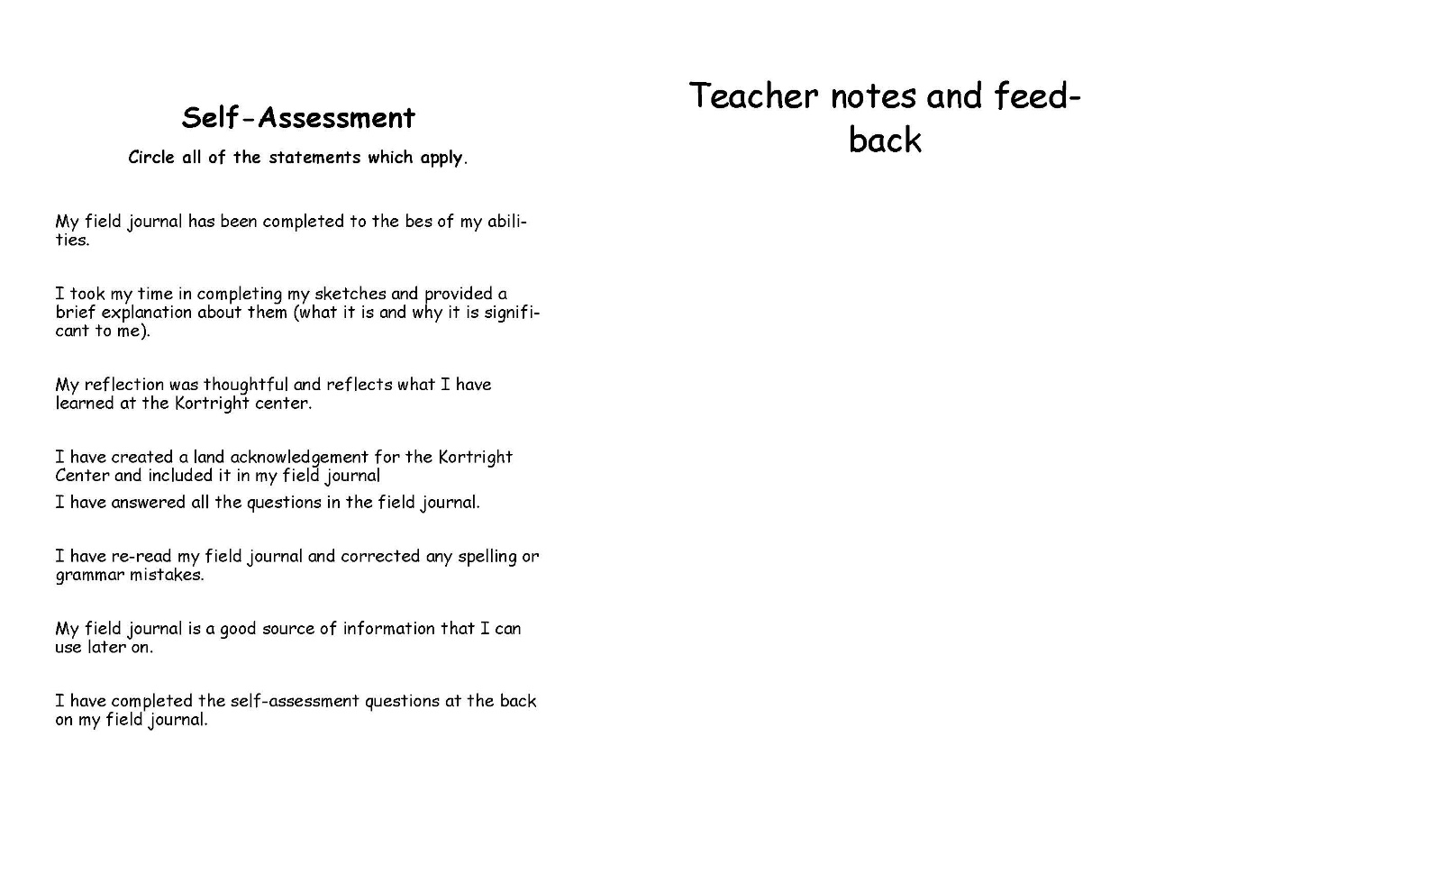

Appendix 3: Class Observation Chart

Student Name | Anecdotal Notes

